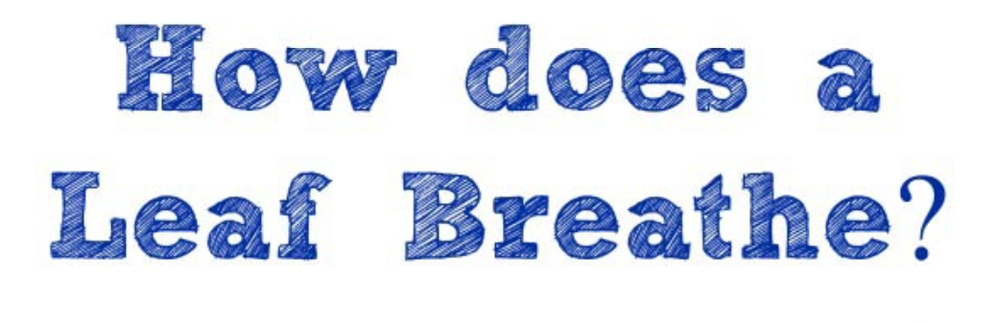

How does a leaf breathe? Does it? Use this experiment to create an environment where you can actually SEE photosynthesis and respiration taking place!

***Step 1:  Fill a large bowl with lukewarm water***

You can use a glass or plastic bowl (personally, I recommend [glass bowls](https://amzn.to/2JSb7YK) better as you'll be able to see the experiment from all angles however you will probably have the bowl outside so you may want to use plastic).

***Step 2:  Head outside and find a large leaf***

You'll want to remove a leaf from a tree or plant and not just pick one up off the ground as we want an 'active' leaf for the project.

***Step 3:  Place the leaf in the bowl of water and put a small rock on top of it so it is FULLY submerged under the water***

Then put the bowl in a sunny spot. As you can see, this is really the benefit of using a glass bowl -- you can be sure your entire leaf is underwater. If you have a place inside that's super sunny, you can also try keeping the bowl there.

***Step 4:  WAIT!***

Oh yea, did I mention that now we need to wait a few hours ;) I know -- one of the hardest things for kids.  So go on with your day -- maybe set the experiment up before lunch or early in the morning. Either way, you can certainly set this up and then go about what you need to do during the day!

***Step 5:  Take a peek a few hours later***

What you should be seeing is small bubbles that form around the leaf and the edges of the bowl… Don’t worry, these are easy to see with the naked eye !

**So what does it all mean…**

**What did you see?**

**Exploring Photosynthesis & Respiration in Plants and Trees**

Ask your kids what would happen if they held their breath, went underwater in the pool and then let their breath out -- they would see bubbles coming up in the water.

That's what they are seeing here -- the leaf is still using the sunlight as part of the photosynthesis process (where leaves convert sunlight to energy).

As a leaf creates that energy, it needs to get rid of the items it no longer needs so it will expel both the extra oxygen during photosynthesis along with water (the release of water from a plant is called transpiration).

The process of photosynthesis is what allows us to see the bubbles -- as the leaf releases its' extra oxygen while submerged, the oxygen can be seen as bubbles in the water. And since oxygen is lighter than water, the bubbles will eventually rise to the surface.

Now does a tree or plant breathe the same as we (humans) do? Nope! A plant, tree or leaf have any lungs or respiratory system.  But it is a living organism just like we are!  It takes in air through their stomata. A human takes in air with oxygen and as they exhale, they release carbon dioxide. Plants take in carbon dioxide from the air and then release oxygen as photosynthesis and respiration occur.

So there you have it -- you can tell your kids they are 'seeing the invisible' because when leaves are on the tree, you aren't able to really see the process of photosynthesis in the works ;)